2. Which of the following statements are true for analog signals?
- They vary continuously in intensity
- They are transmitted in parts of the telephone network
- They are compatible with human senses
- They can be processed electronically
- All of the above
3. Which of the following statements are
true for digital signals?
- They can encode analog signals
- They are transmitted in parts of the telephone network
- They can be processed electronically
- They are used in computer systems
- All of the above
4. You digitize a 10 kHz signal by sampling
it at twice the highest frequency and
encoding the intensity in 8 bits. What is
the resulting data rate?
- 20 kbit/s
- 64 kbit/s
- 144 kbit/s
- 160 kbit/s
- 288 kbit/s
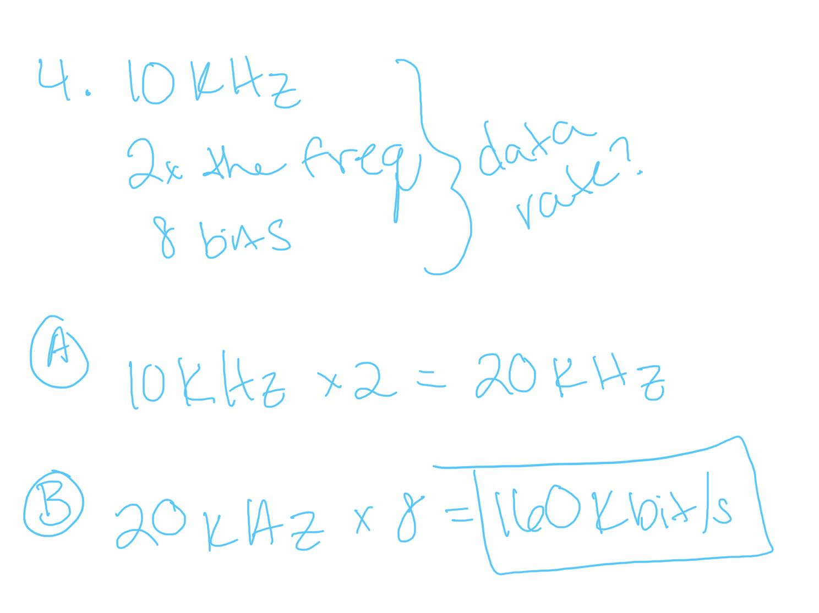
7. Time division multiplexing of eight
signals at 150 Mbit/s each produces
- Eight optical channels each carrying 150 Mbit/s
- One channel carrying 120 Mbit/s
- One channel carrying 1.2 Gbit/s
- Eight signals at 150 MHz

9. The carrier signal modulated to
produce one optical channel in a
fiber-optic system is
- A single wavelength of light generated in the transmitter
- A radio-frequency signal supplied electronically to the transmitter
- An acoustic vibration in the optical fiber
- A combination of wavelengths generated by several light sources
11. What is the only important
telecommunications system that uses
fiber transmit analog signals?
- Local telephone service
- Long distance telephone systems
- Internet backbone systems
- Cable TV systems
- None

